Packet Sniffing and Spoofing Lab

Brandon Givens

N00649313

Task 1.1B. Usually, when we sniff packets, we are only interested in certain types of packets. We can do that by setting filters in sniffing. Scapy’s filter use the BPF (Berkeley Packet Filter) syntax; you can find the BPF manual from the Internet. Please set the following filters and demonstrate your sniffer program again (each filter should be set separately):

• Capture only the ICMP packet

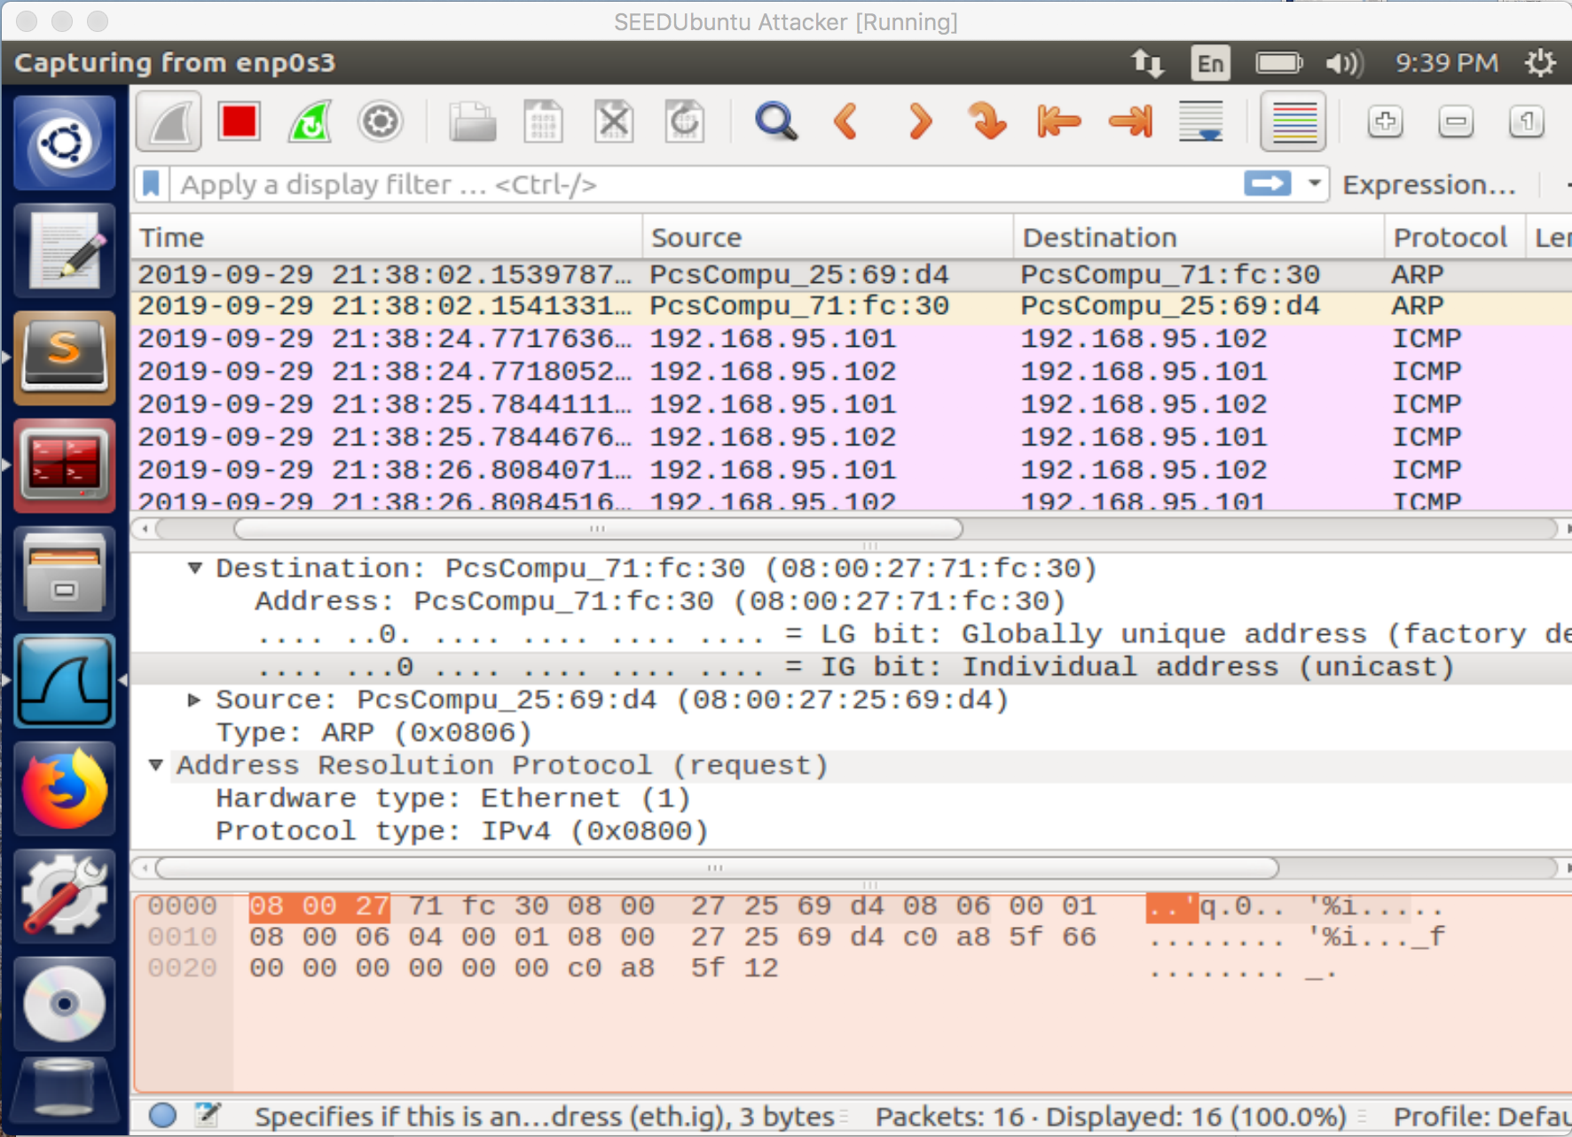

Figure 1: Here you can see that the Sniffer has found the ICMP packets between 192.168.95.101 and 192.168.95.102

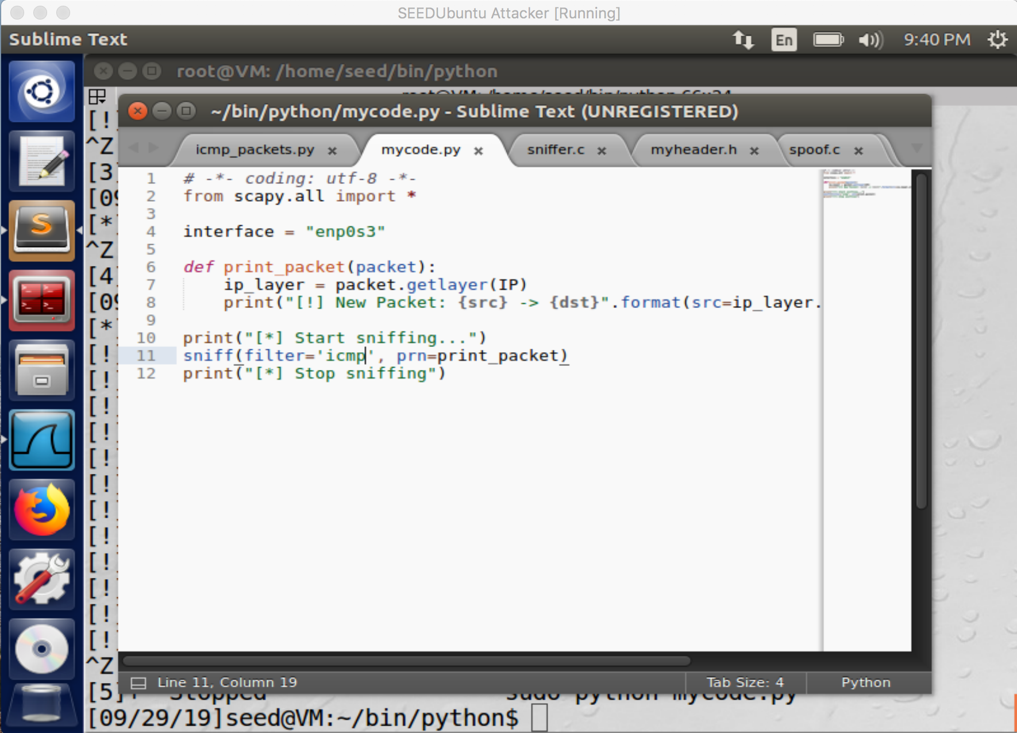

Figure 2: Here in the code you can see where we specify the interface that we’ll be sniffing and the filter we’ll use when going through the packets.

• Capture any TCP packet that comes from a particular IP and with a destination port number 23.

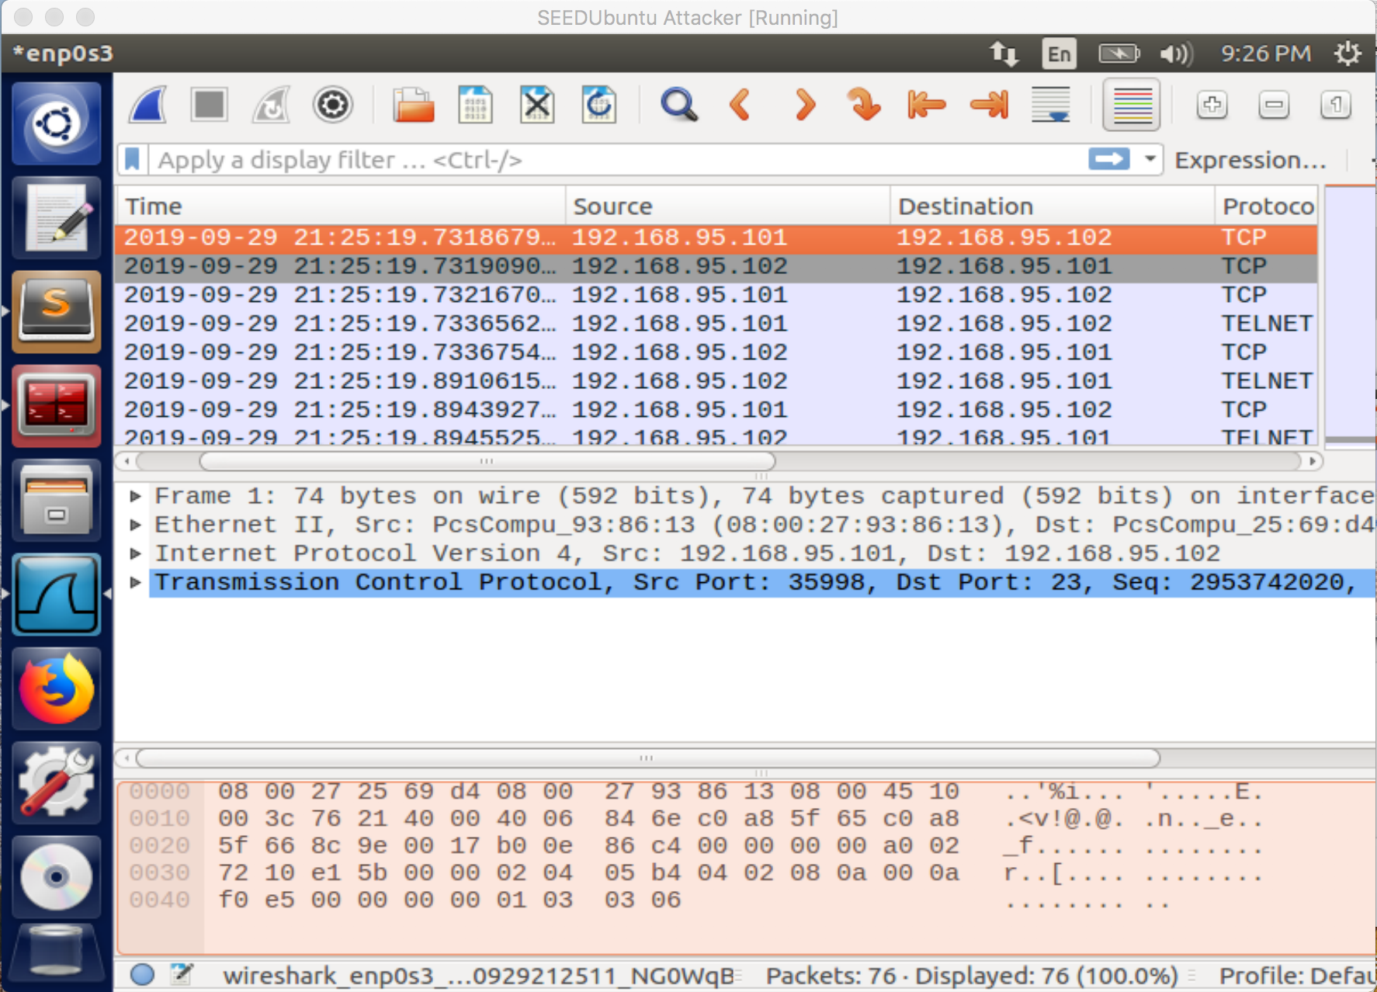

Figure 3: Here Wireshark is showing that the packets sniffed out are TCP packets with the destination of port 23.

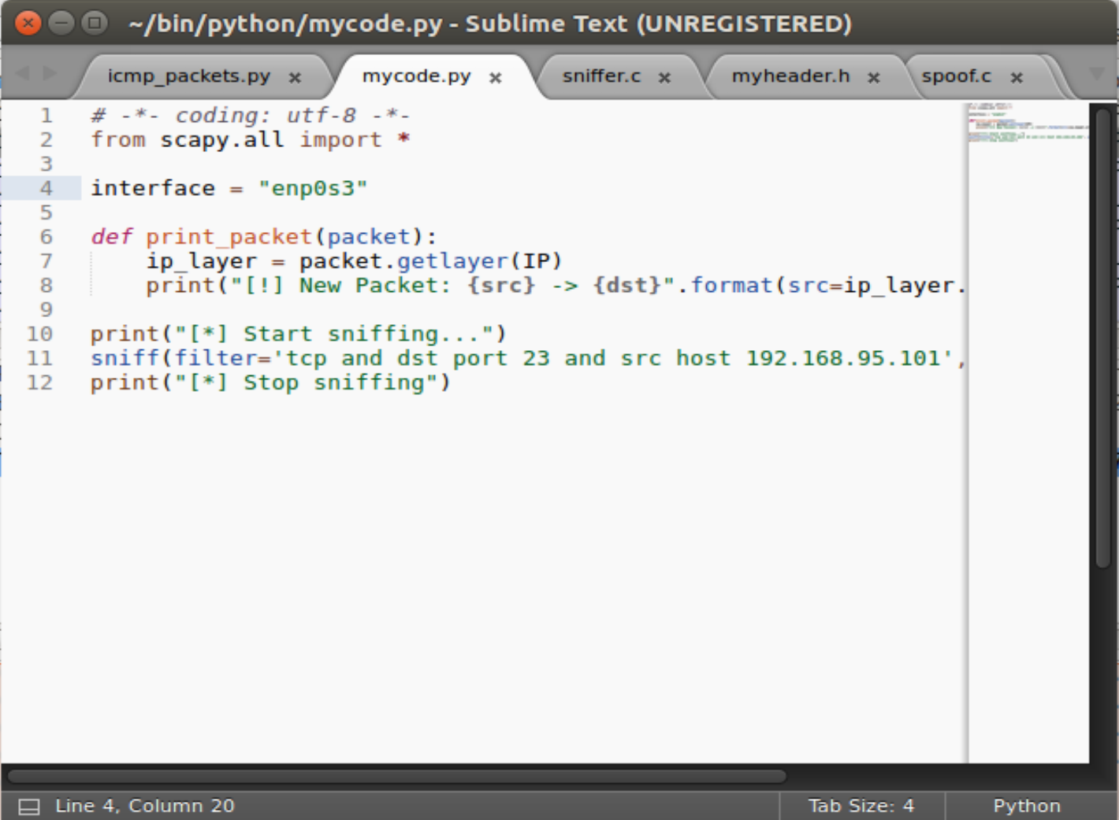

Figure 4: This is a piece of the code that specifies the filter for the packets we are sniffing, TCP packets, dst port 23 and the host IP.

• Capture packets comes from or to go to a particular subnet. You can pick any subnet, such as 128.230.0.0/16; you should not pick the subnet that your VM is attached to.

2.2 Task 1.2: Spoofing ICMP Packets

Please make any necessary change to the sample code, and then demonstrate that you can spoof an ICMP echo request packet with an arbitrary source IP address.

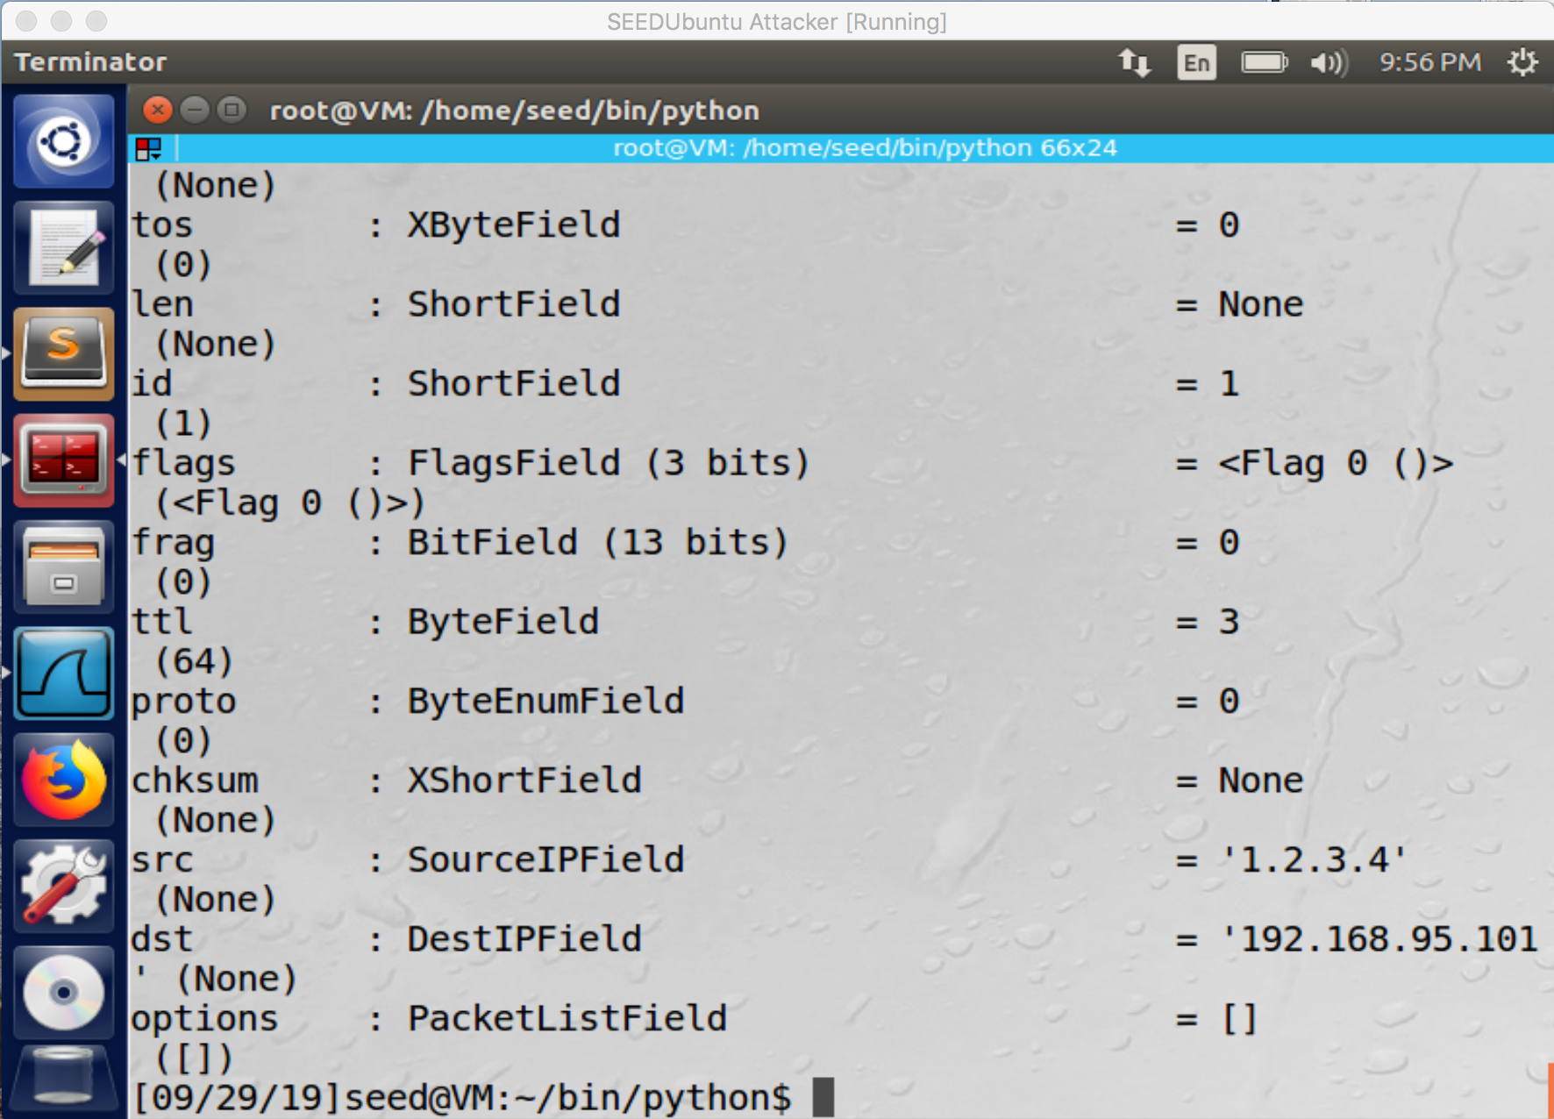

Figure 5: In this screenshot we can see that the source IP has been spoofed to a fake IP address.

2.3 Task 1.3: Traceroute

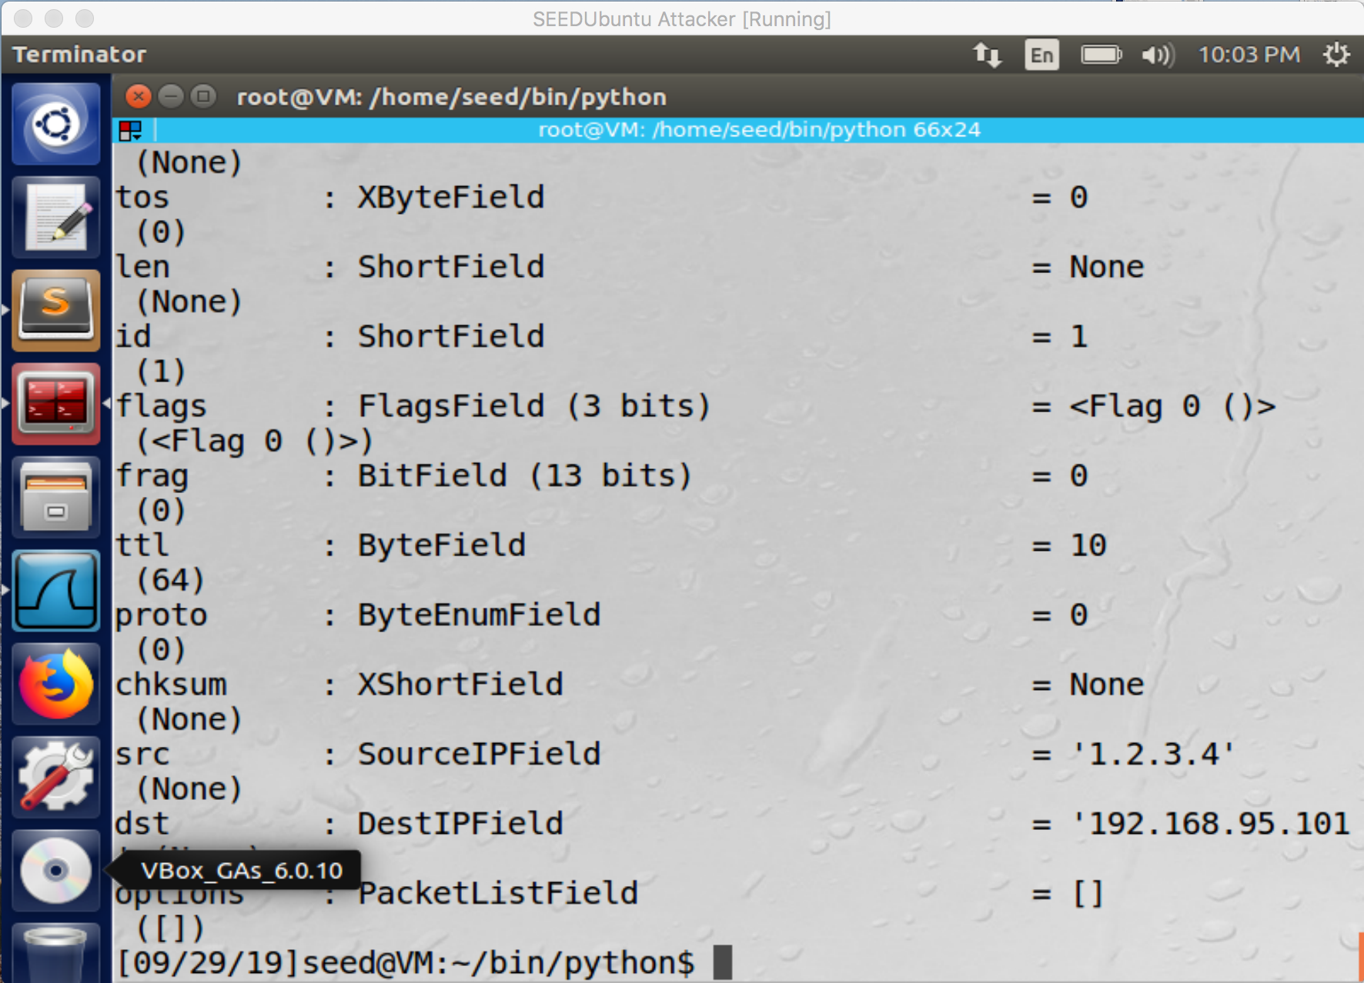

Figure 6: In this screenshot if you look at the ‘TTL’ the number was increased from 3 to 10.

Even though I continued to increase the TTL, I didn’t receive any error message or reply from the destination IP in regards to the packets.

Task 1.4: Sniffing and-then Spoofing

Whenever it sees an ICMP echo request, regardless of what the target IP address is, your program should immediately send out an echo reply using the packet spoofing technique. Therefore, regardless of whether machine X is alive or not, the ping program will always receive a reply, indicating that X is alive. You need to use Scapy to do this task. In your report, you need to provide evidence to demonstrate that your technique works.

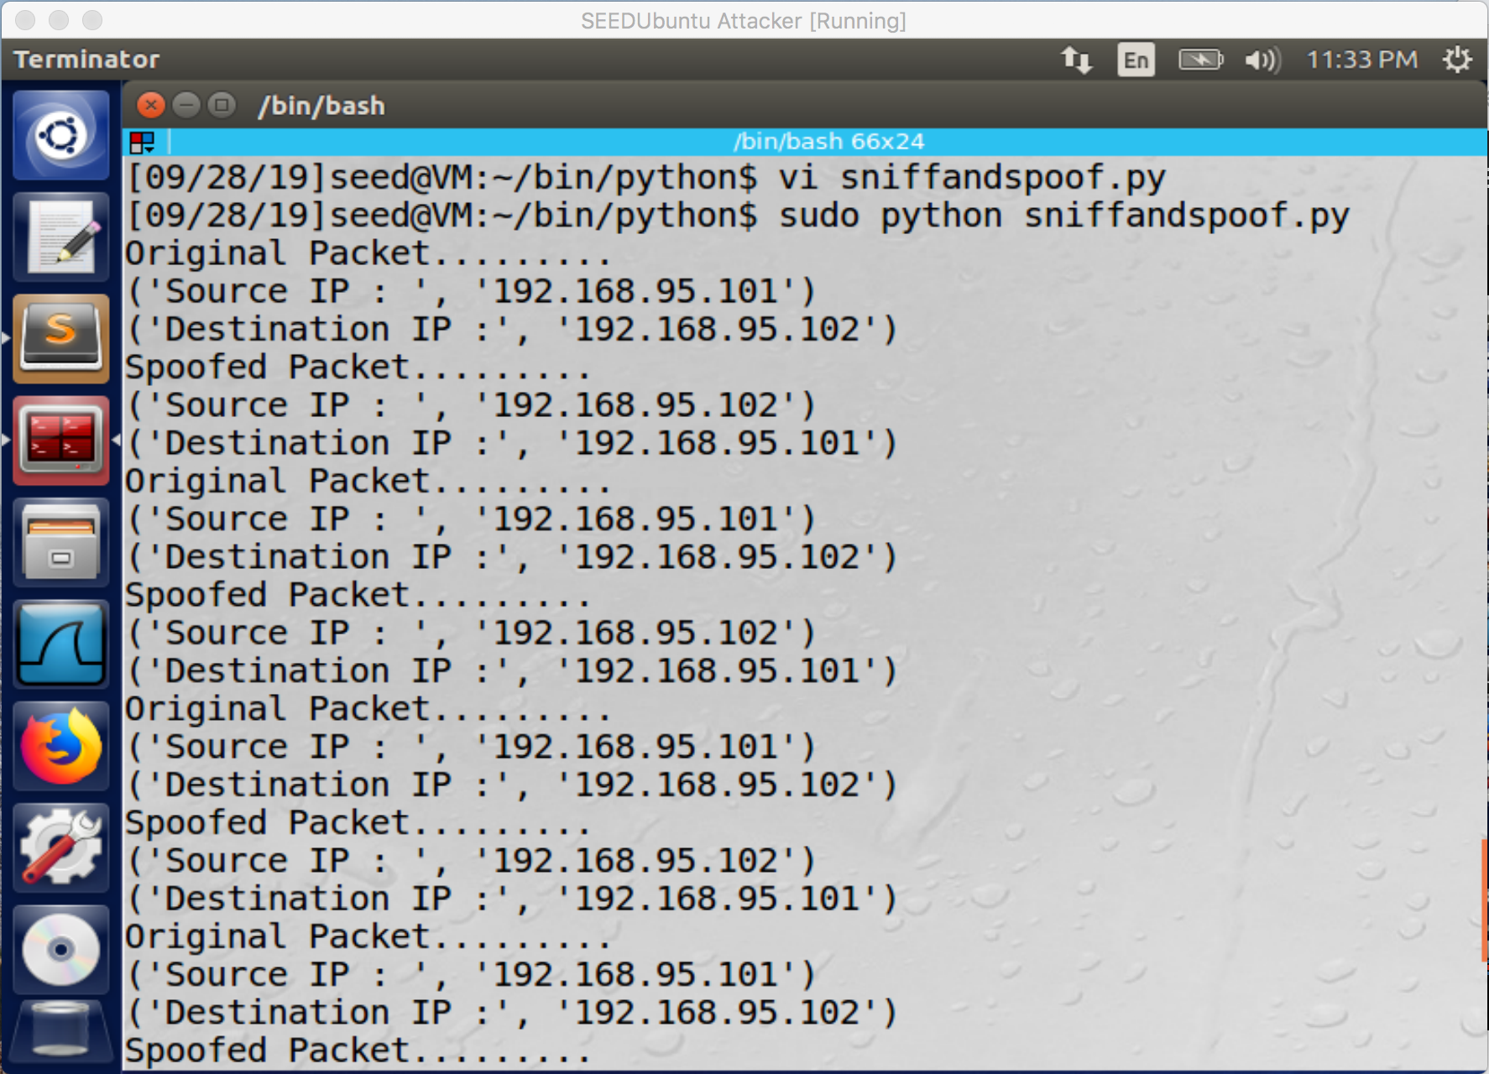

Figure 7: Using the sniffandspoof.py program the attacker can see what the source IP and destination IP for the packets are. Also we can see that after the packet info is picked up, the attacker spoofs the packet and replies to the packet.

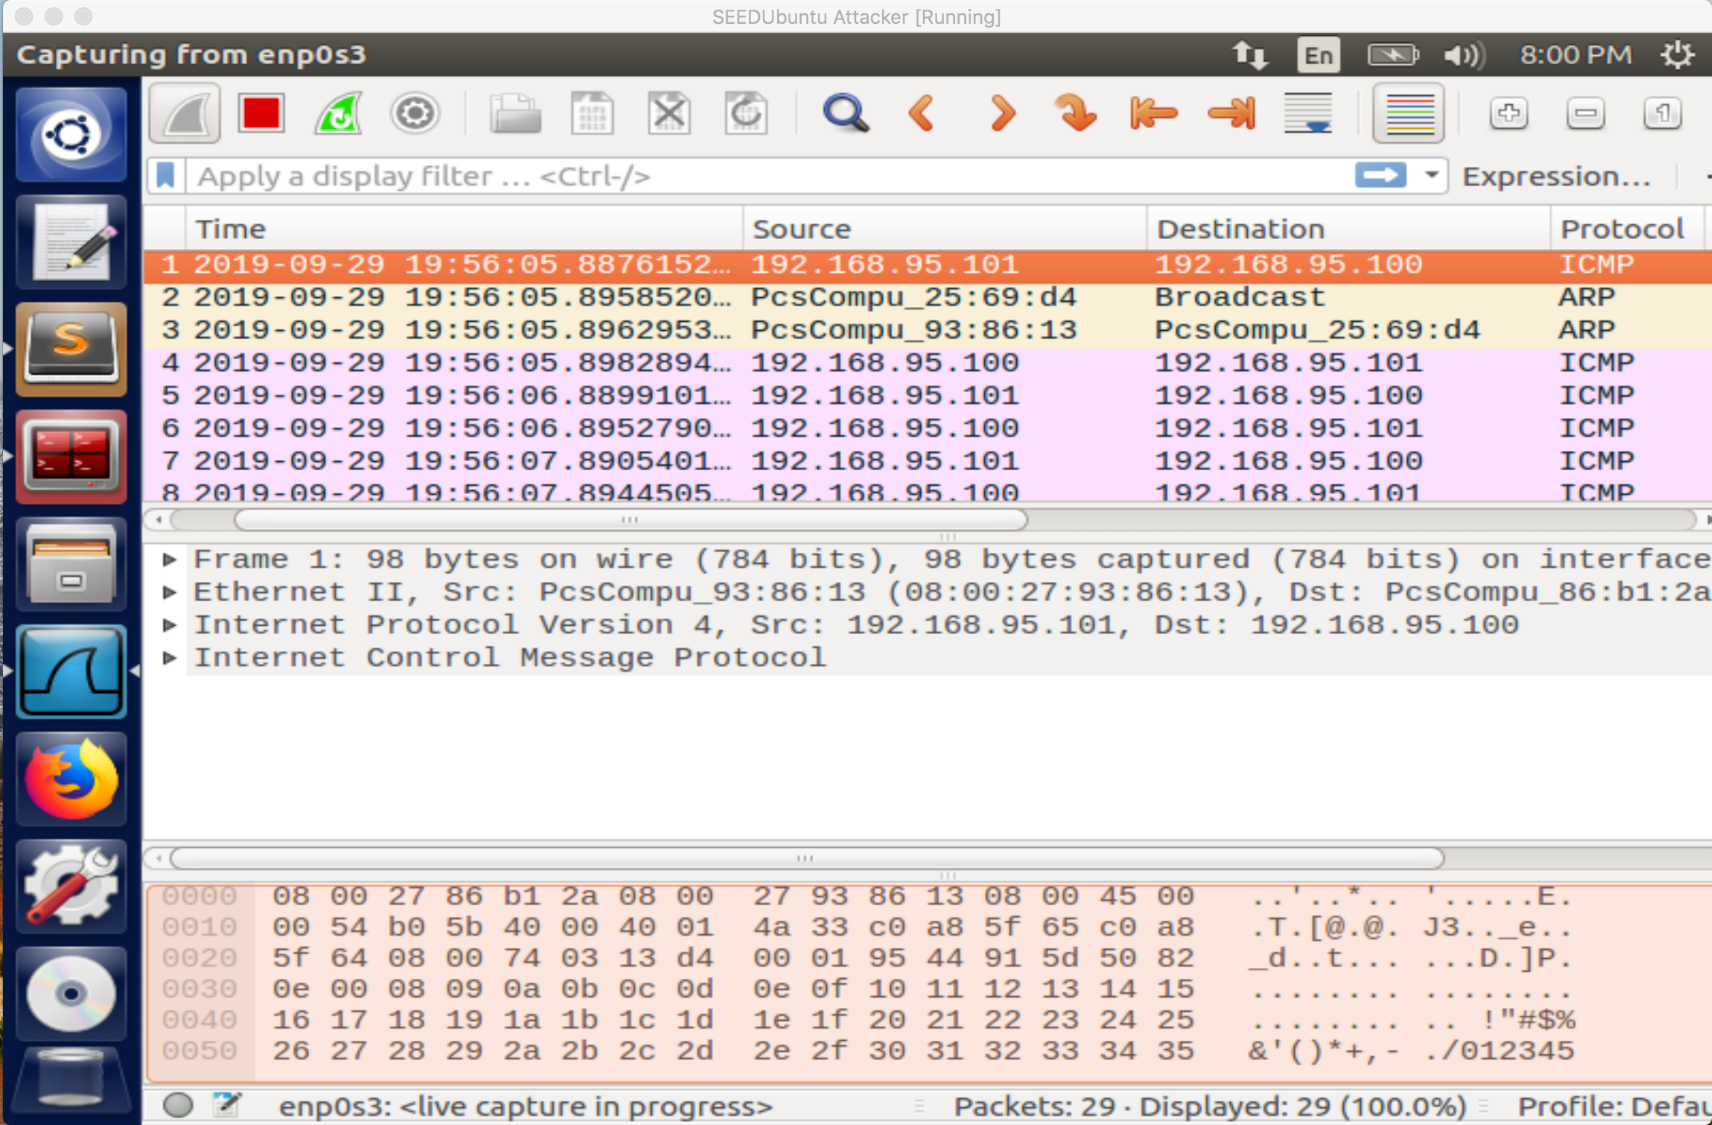

Figure 8: Here we can see that in fact even with the user machine being powered off we are still getting replies to the PING from the Server machine.

Task 2.1: Writing Packet Sniffing Program

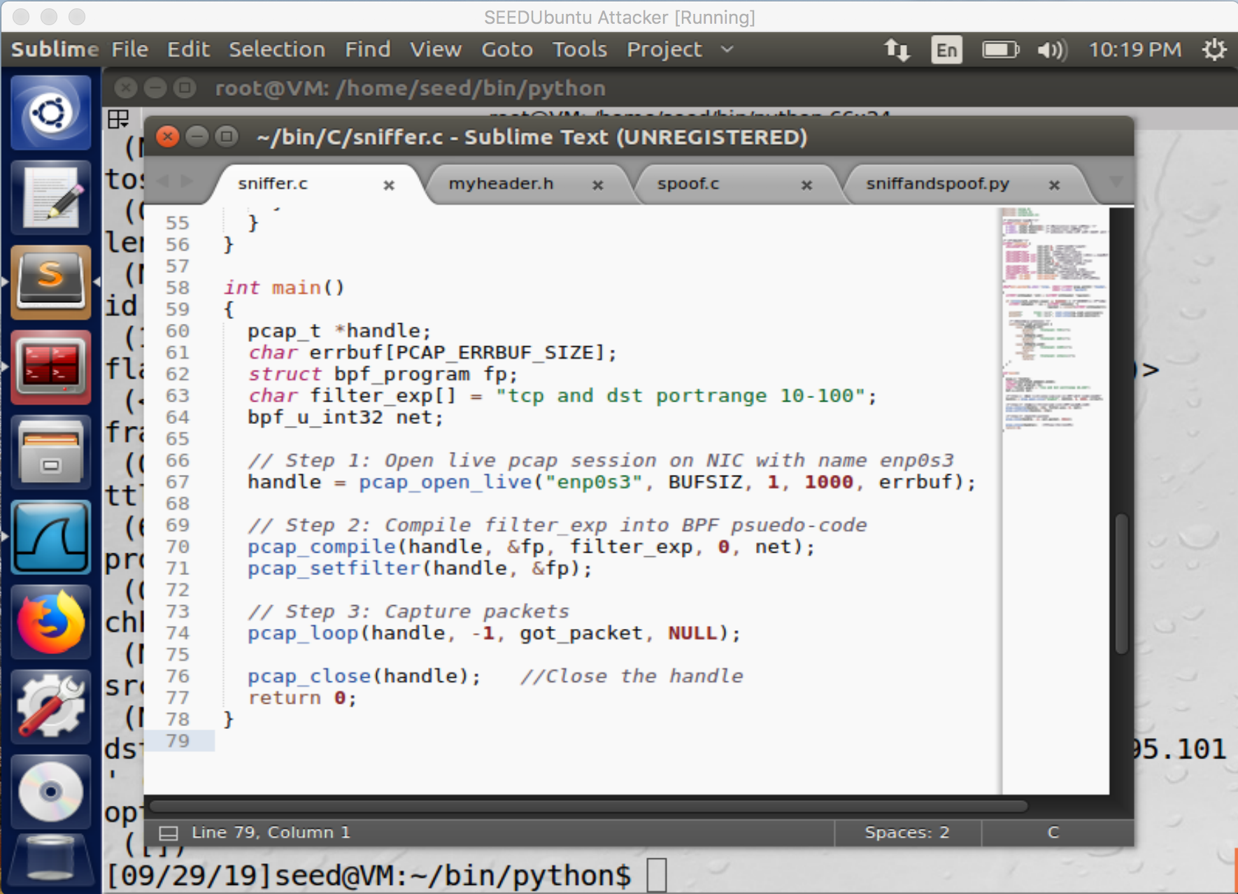

Figure 9: Here we can see a part of the sniffer program in C, similar to the python program we can filter the packets we are sniffing for. As well as the interface and other conditions.

Task 2.1A:

Question 1. Please use your own words to describe the sequence of the library calls that are essential for sniffer programs. This is meant to be a summary, not detailed explanation like the one in the tutorial or book.

A: Setting up the device.

First we start out setting up the device and also by deciding the interface that we want to start capturing with (a common one is eth0). In the code that we are using, instead of defining the device in a string we are using pcap_lookupdev to find the device automatically.

Find Properties for the Device.

Next in the sniffer program we use pcap_lookupnet to find properties for the device we will be using, this includes the IPv4 network number and the netmask for the device.

Open the Session.

Here we are initializing the sniffer to create the environment for where the sniffing will take place, this is called a session. The session is opened in promiscuous mode, this allows a network device to intercept and read every packet that arrives.

Compile and Apply Filters.

Here we are defining specific filters we want for the session (kind of like rules) that we want followed when sniffing and analyzing packets.

Grab a packet.

The program is run and a packet is grabbed using the filters we set in the previous section of code, next printing out the length of the packet that has been grabbed. After the session is ended once the requirements have been met.

Question 2. Why do you need the root privilege to run a sniffer program? Where does the program fail if it is executed without the root privilege?

A: The pcap_lookupdev() function needs root privilege because it wants to access the network interfaces which it can’t do without the root privileges. Raw sockets are what our sniffer program needs that allow the direct sending of packets by the application, bypassing every application in the network software of OS. You can’t create raw sockets unless we are a root user.

Question 3. Please turn on and turn off the promiscuous mode in your sniffer program. Can you demonstrate the difference when this mode is on and off? Please describe how you can demonstrate this.

A: When promisc mode is on your are able to see the sniffed packets but when promisc mode is not on, you are unable to see them. By my testing for some reason I get the same results whether promisc mode is on or off.

Run the program again, but without using the root privilege; describe and explain your observations :

A: The python will run without any issues with root privileges but without those privileges the operation will not be permitted.

Demonstrate that you can spoof an ICMP echo request packet with an arbitrary source IP address :

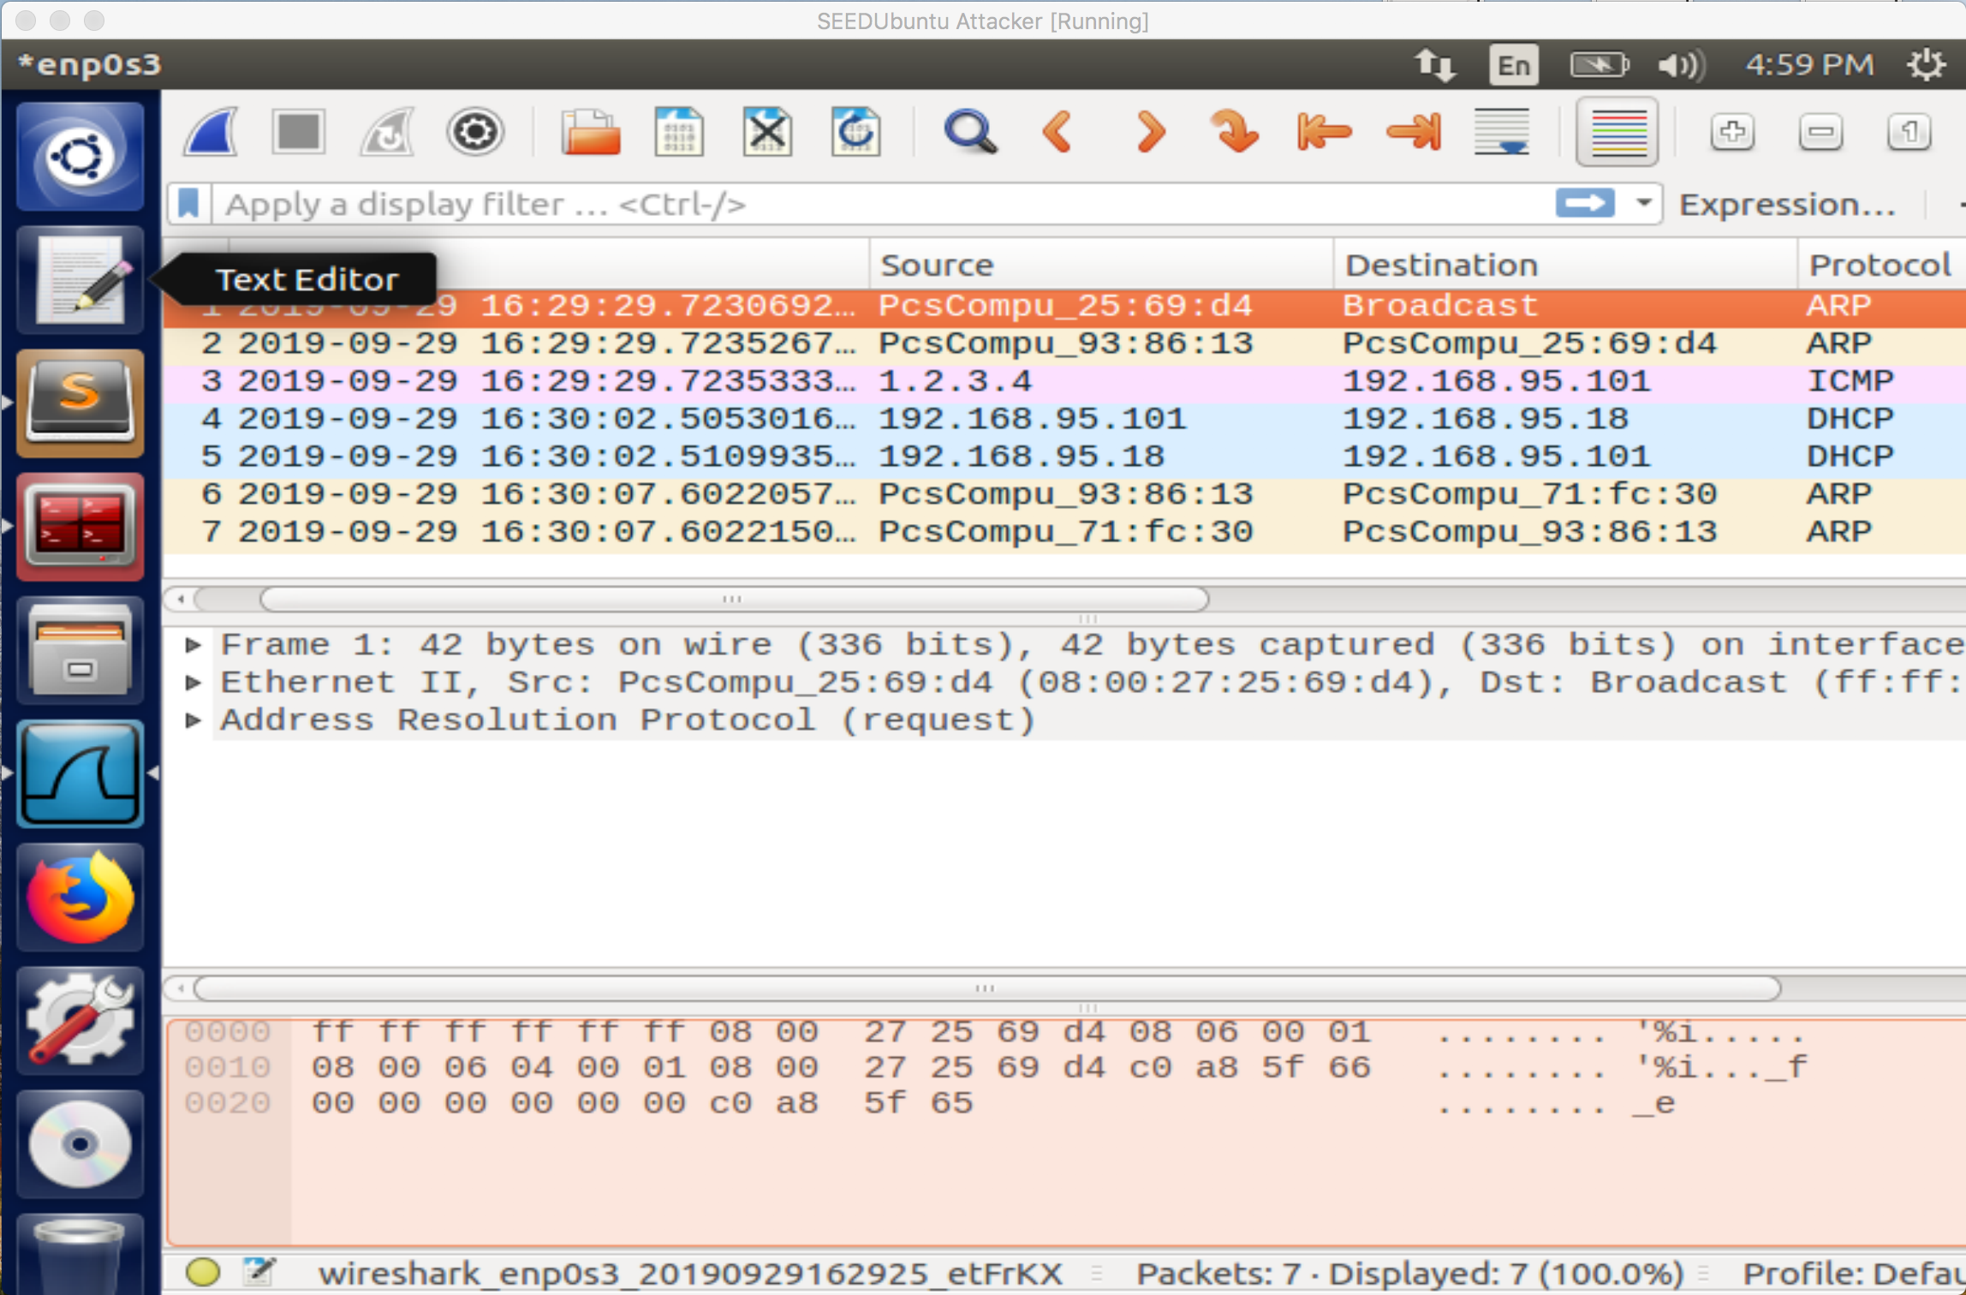

Figure 10: In Wireshark we can see that in fact an ICMP packet has been sent to the dst IP from our made-up source IP address.

Results from running the Sniffer program, first with no root privileges and runs after with root privileges:

With root privileges, you are able to run the sniffer program but without root (or sudo) it causes a segmentation error which is due to not having the privileges to run the sniffer program.

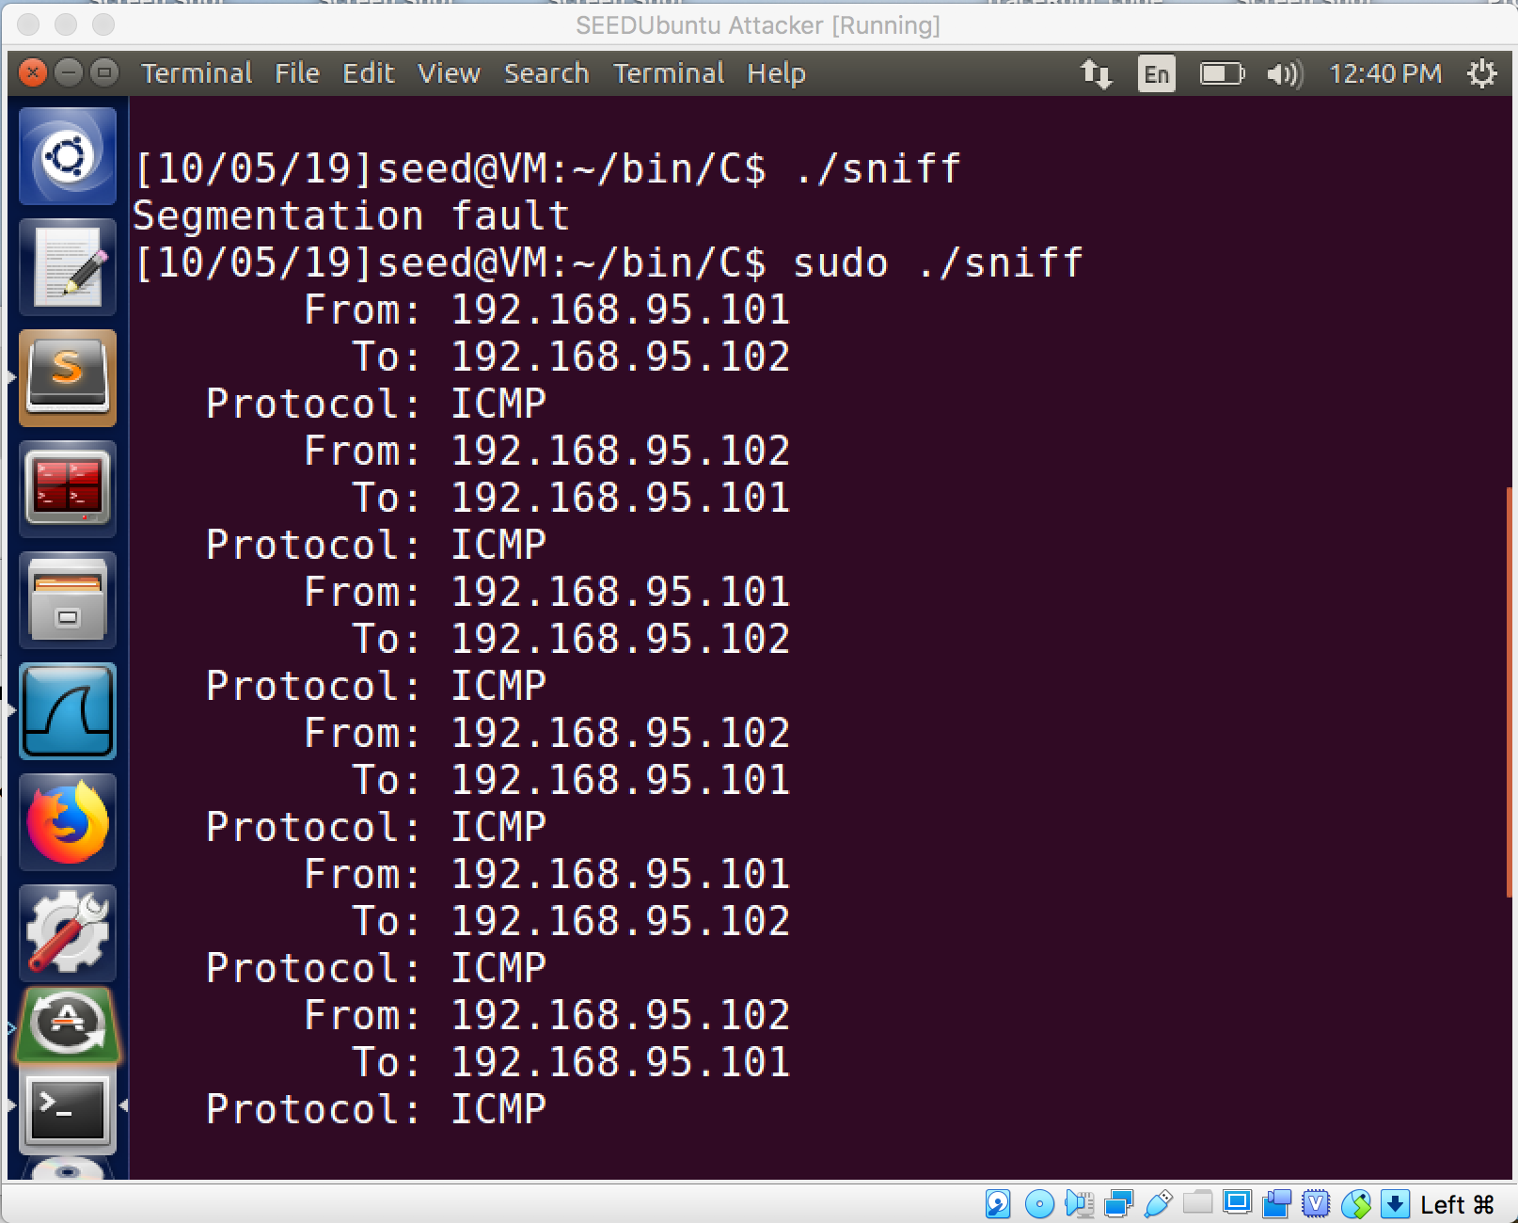

Figure 11: This screenshot just shows the difference between trying to run the program without root privileges and running it with root privileges.

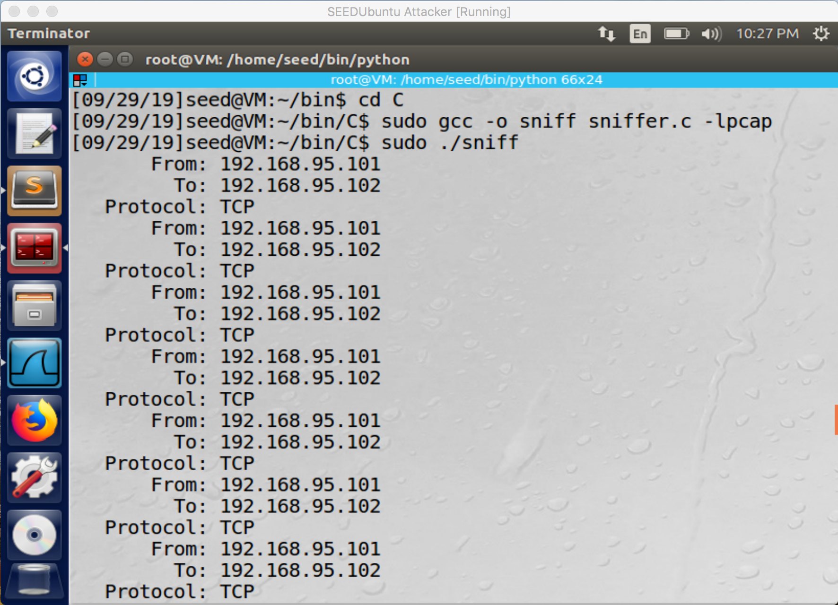

Figure 12: Here we are just seeing where the packet is coming from and where the packet’s destination is, as well as the protocol of the packet (in this case ‘TCP’).

Task 2.1B: Writing Filters. Please write filter expressions for your sniffer program to capture each of the followings. You can find online manuals for pcap filters. In your lab reports, you need to include screenshots to show the results after applying each of these filters.

• Capture the ICMP packets between two specific hosts.

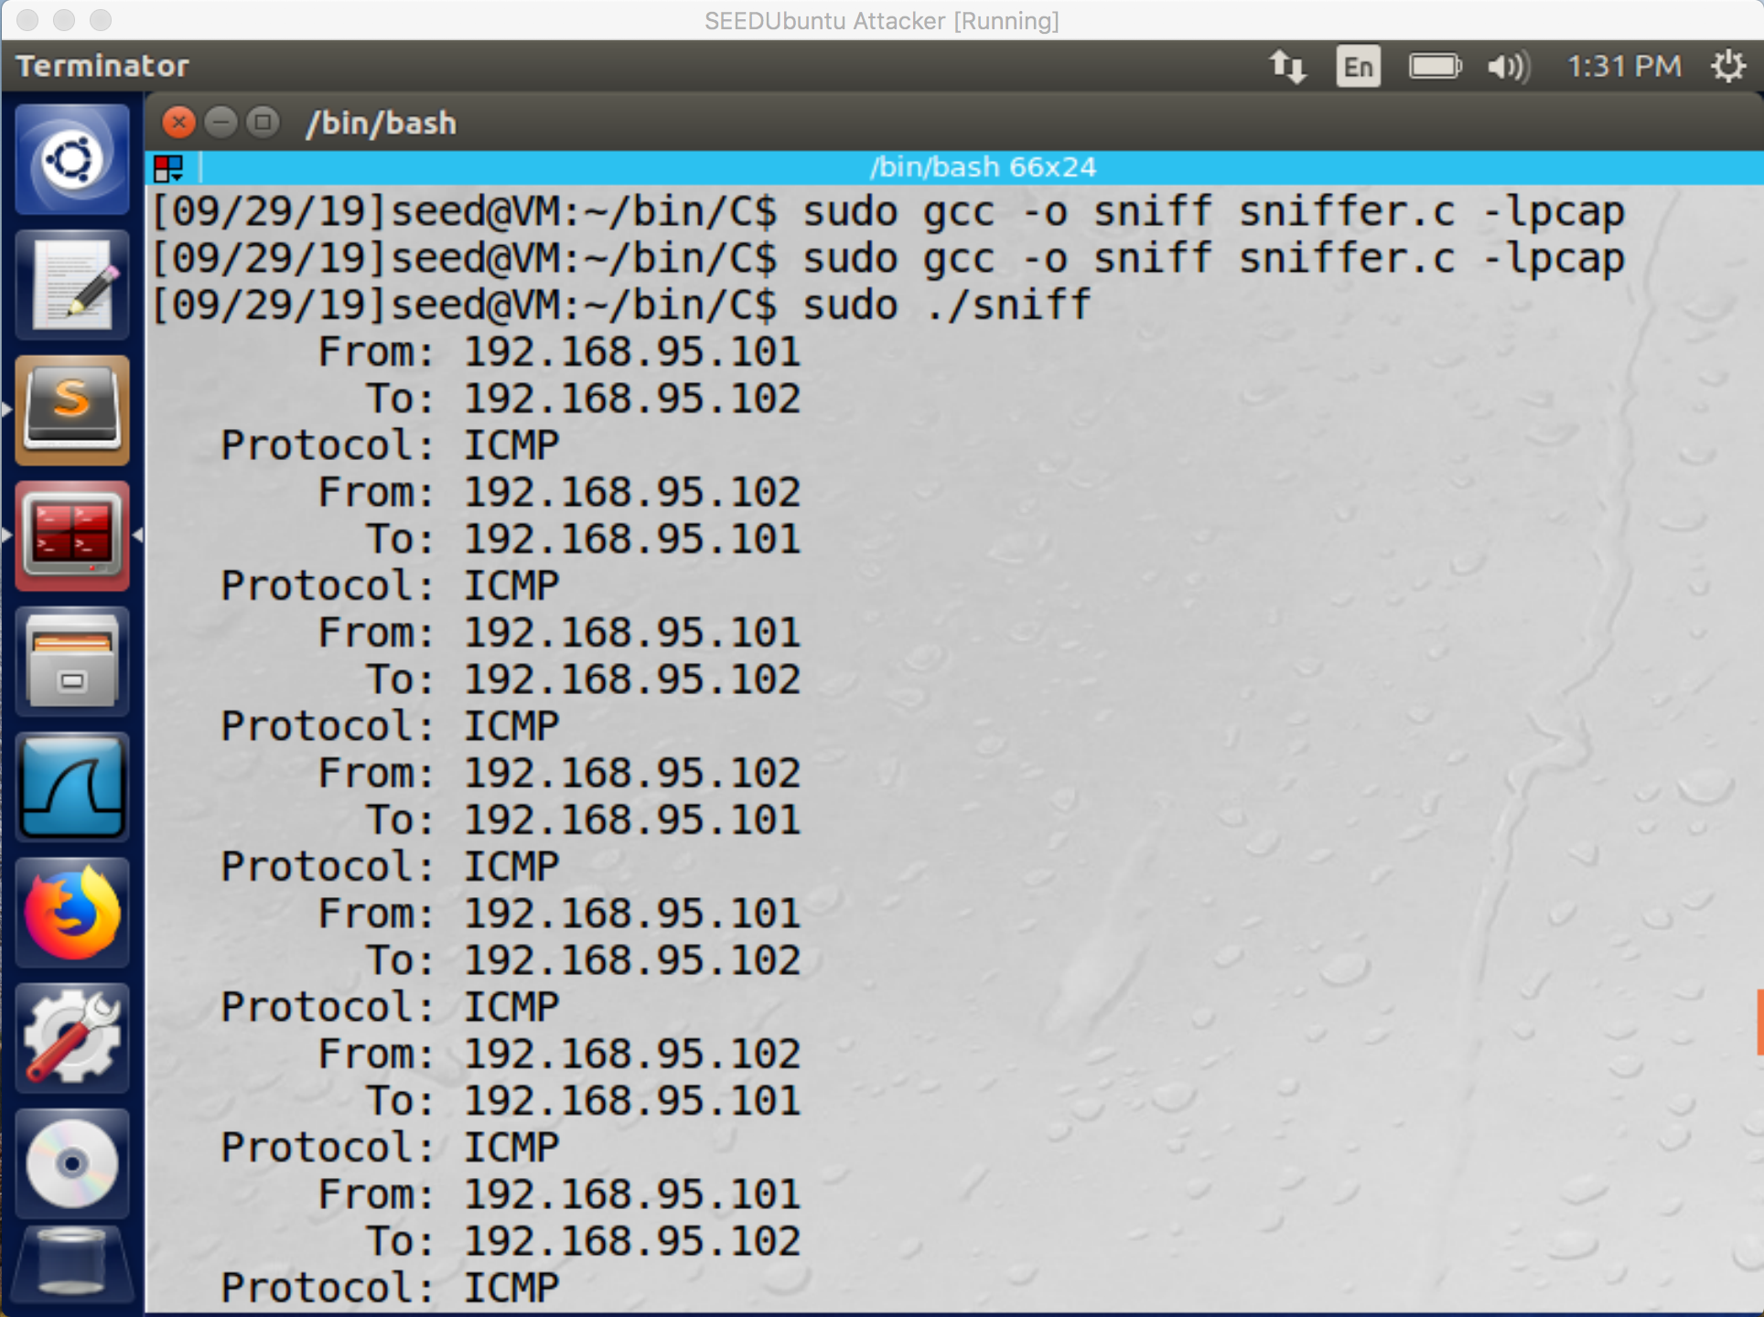

Figure 13: Here is the result for sniffing for the ICMP packets from two specific host.

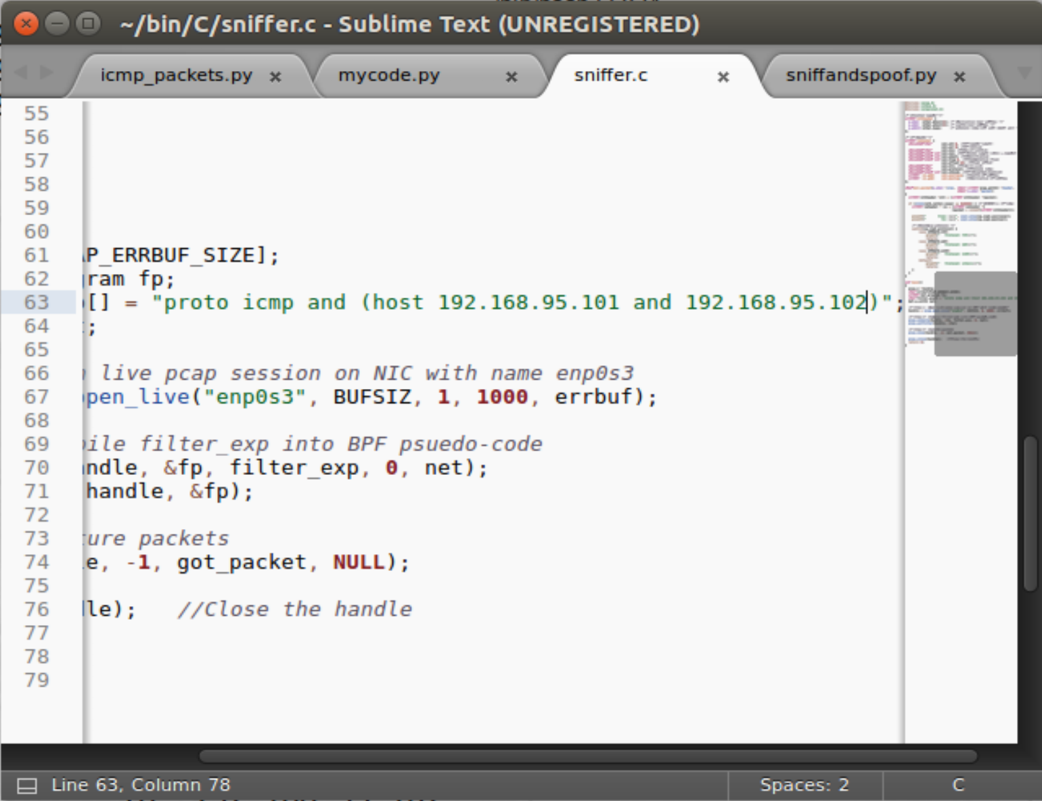

Figure 14: This is a screenshot of the code showing the filter syntax to filter out the packets.

• Capture the TCP packets with a destination port number in the range from 10 to 100.

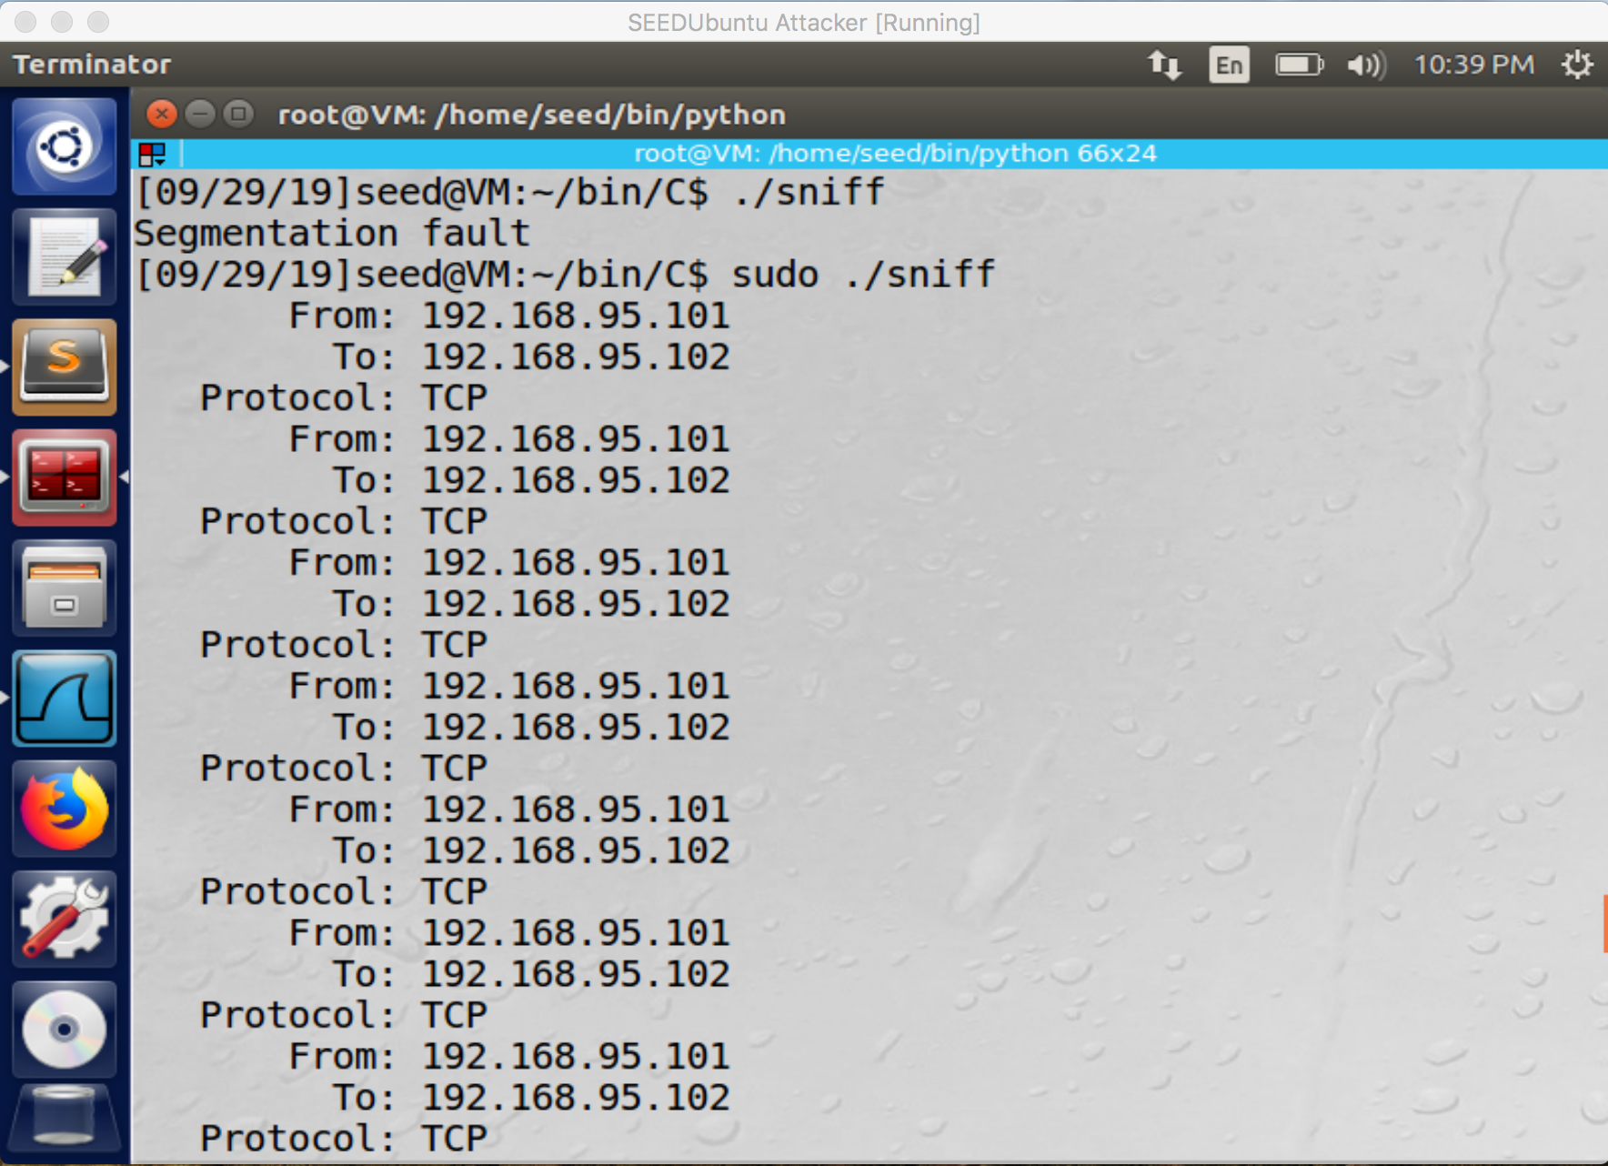

Figure 15: This is the result of the condition above.

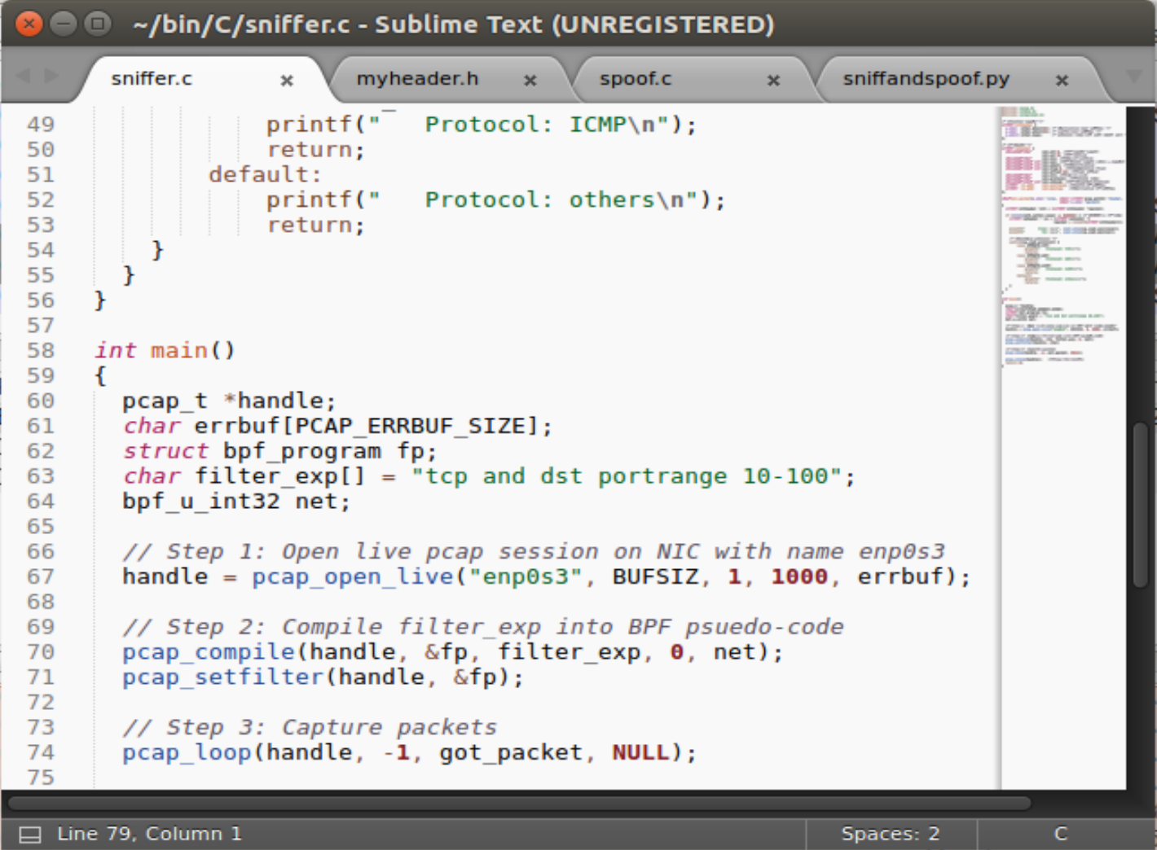

Figure 16: This is the filter syntax used to execute the condition above.

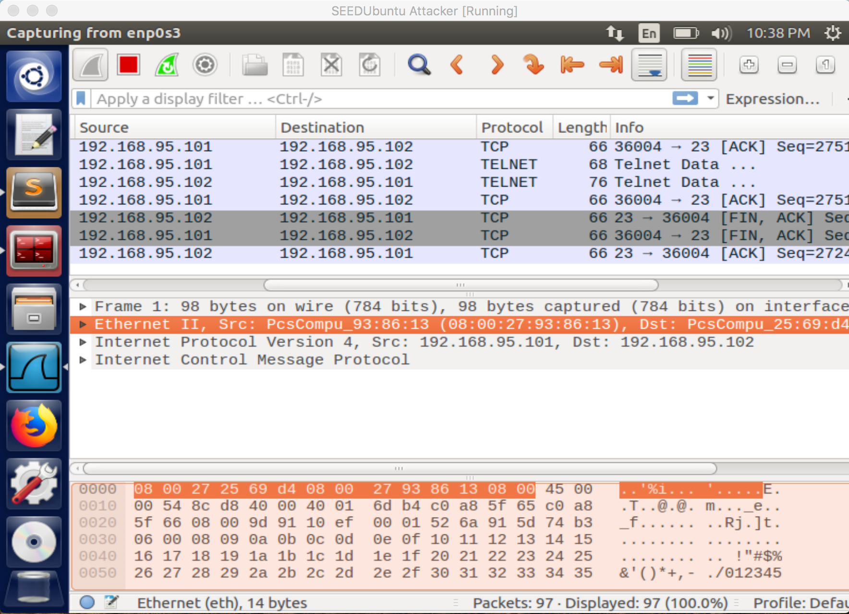

Figure 17: Here in Wireshark we can see that the filter sniffed out the correct packets based on the condition above.

3.2 Task 2.2: Spoofing

Task 2.2A: Write a spoofing program. Please write your own packet spoofing program in C. You need to provide evidence (e.g., Wireshark packet trace) to show that your program successfully sends out spoofed IP packets.

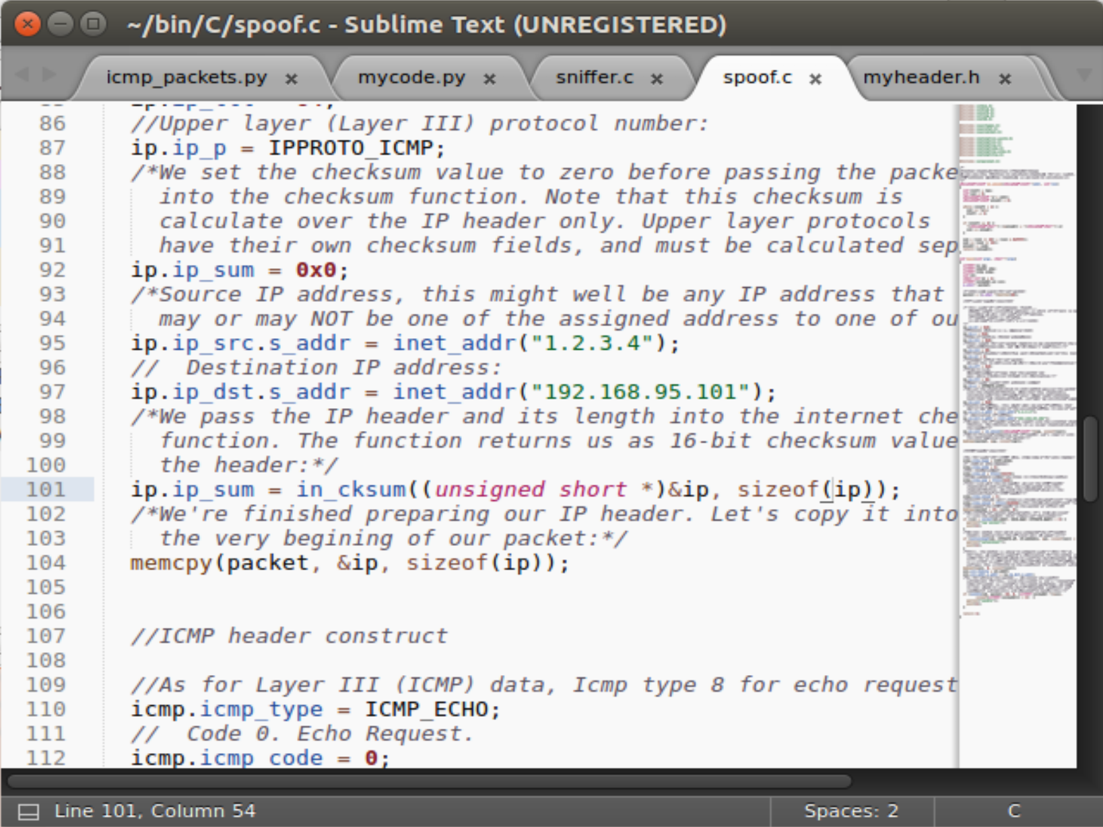

Figure 18: This is a screenshot of the spoof code, here we can see where we can input our desired source IP and input the destination IP for the program.

Task 2.2B: Spoof an ICMP Echo Request. Spoof an ICMP echo request packet on behalf of another machine (i.e., using another machine’s IP address as its source IP address). This packet should be sent to a remote machine on the Internet (the machine must be alive). You should turn on your Wireshark, so if your spoofing is successful, you can see the echo reply coming back from the remote machine.

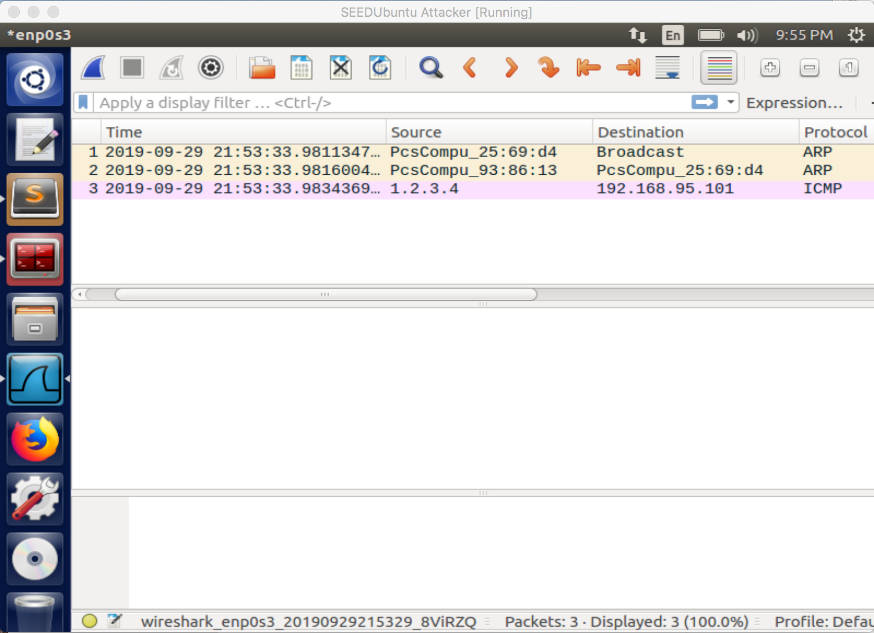

Figure 19: Here in Wireshark we can see that a spoof ICMP packet has been sent from our made-up source IP address.

Unfortunately, with both of these attempts I got no responses back, I tried many times and no matter the server machine wouldn’t respond.

Questions.

Please answer the following questions.

• Question 4. Can you set the IP packet length field to an arbitrary value, regardless of how big the actual packet is?

The length field in this case should be the length of the IP packet, if not the sendto method (or function) will show an error ‘Invalid Argument’. So yes, it is important that it is the length of the IP packet.

• Question 5. Using the raw socket programming, do you have to calculate the checksum for the IP header?

No you don’t need to calculate the checksum, it will be filled by the system.

• Question 6. Why do you need the root privilege to run the programs that use raw sockets? Where does the program fail if executed without the root privilege?

Its restricted to root because it would break some rules for networking that are in place, without root you can not bind a port lower than 1024. With raw sockets you can simulate a server on any port and spoof custom packets which can interfere with inbound traffic.

3.3 Task 2.3: Sniff and then Spoof

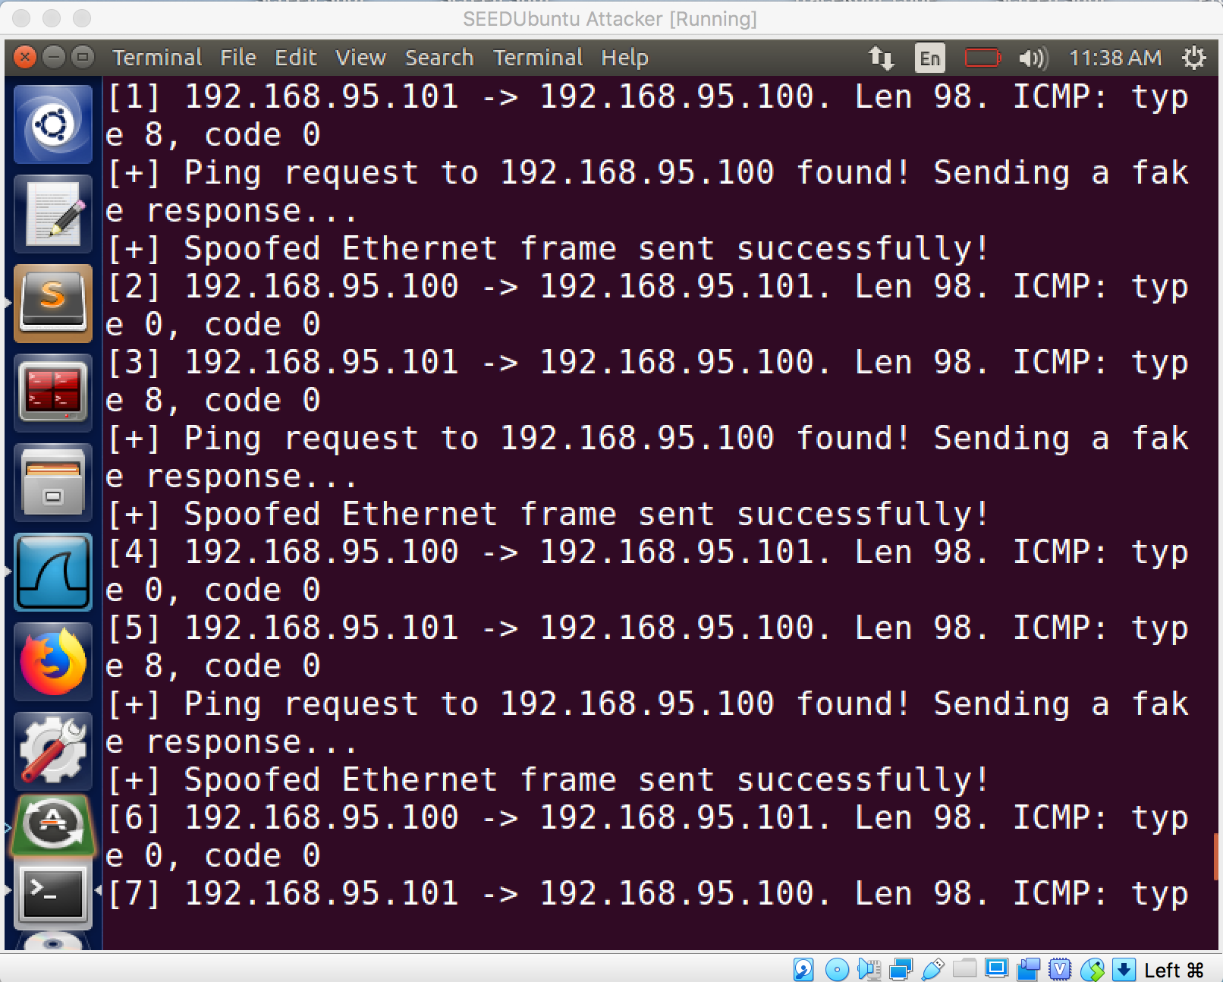

Figure 20: This is the terminal of the Attacker, as we can see the Attacker has sniffed out the PING from the server machine to the user machine (powered off). And is spoofing a reply back to the server machine from the Attacker machine as the user machine.

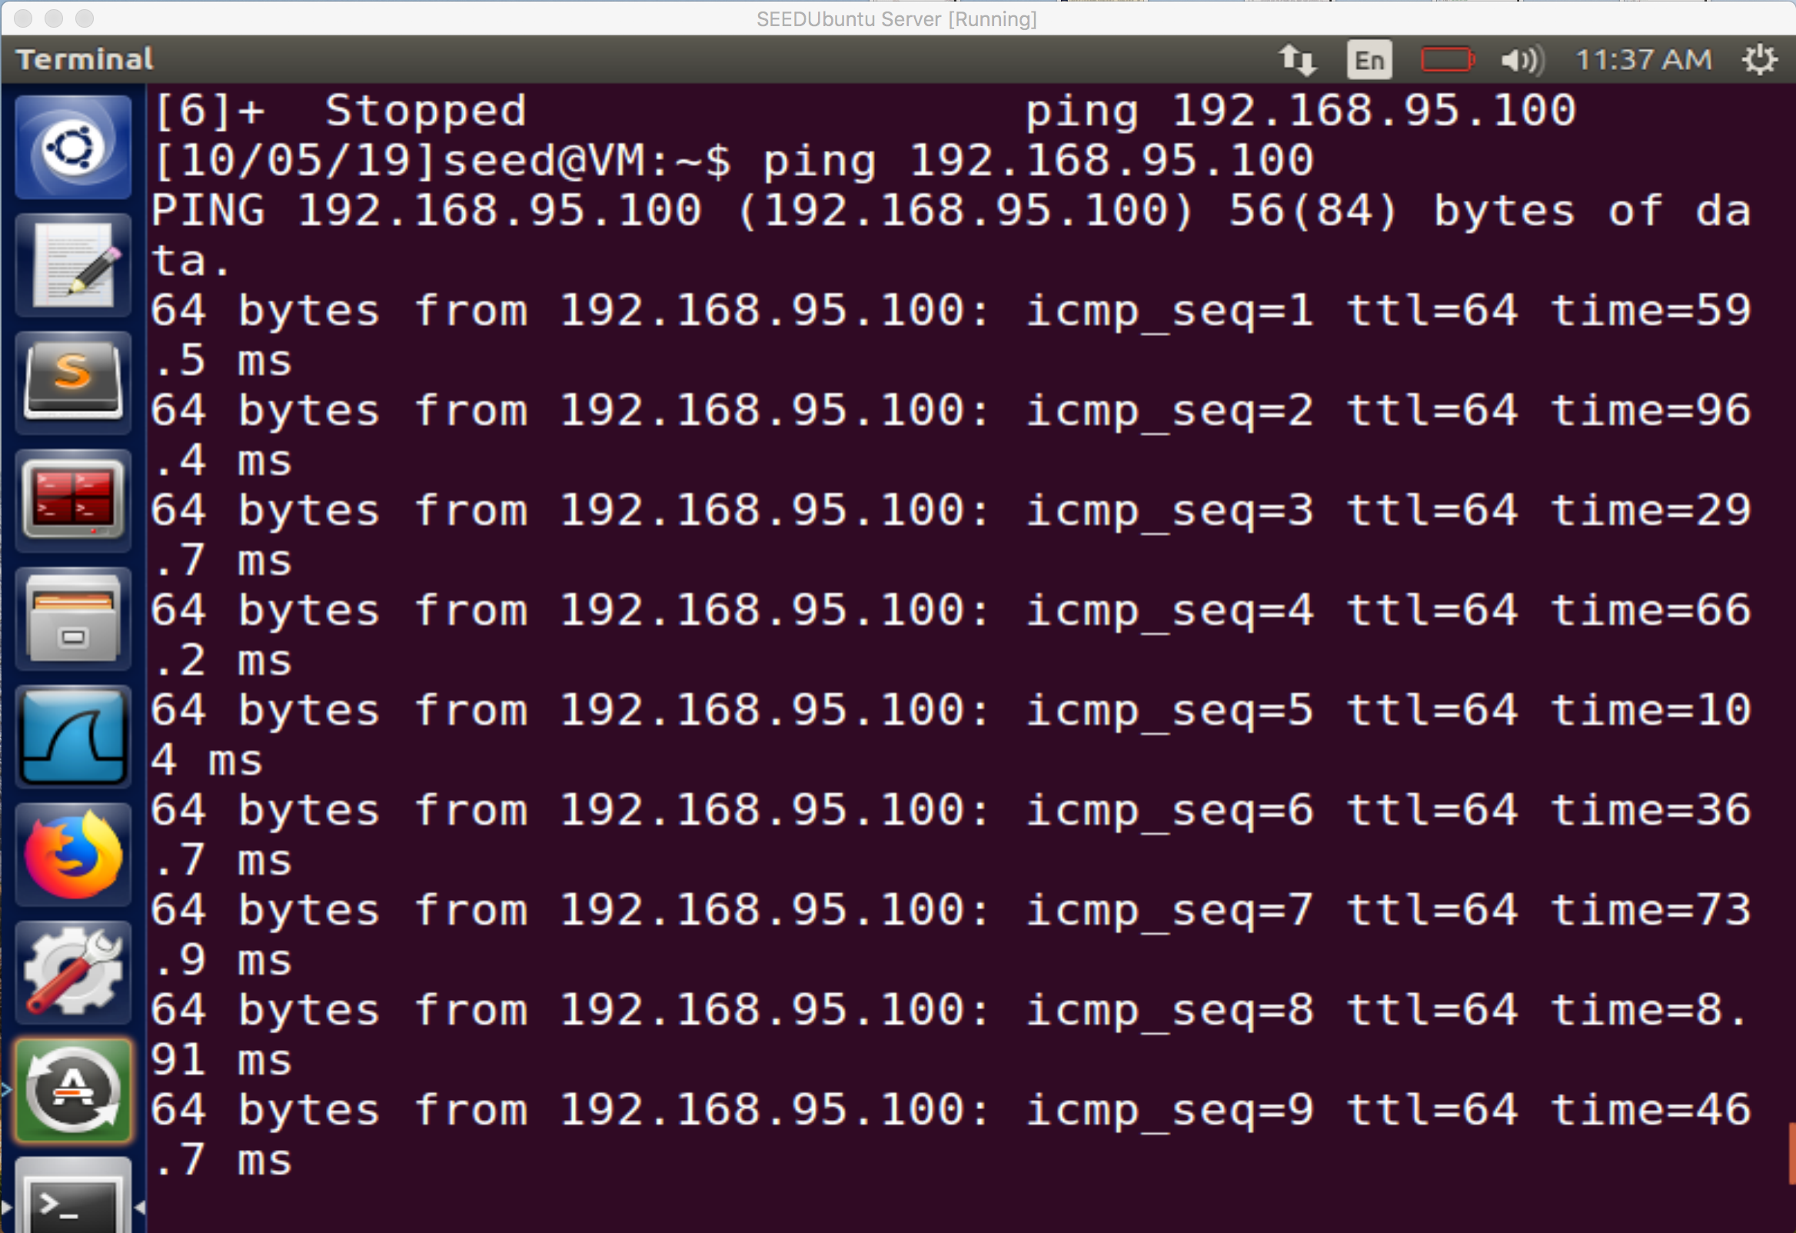

Figure 21: Here is the response on the Server machine, showing that even though the user machine is off it’s still getting responses back.

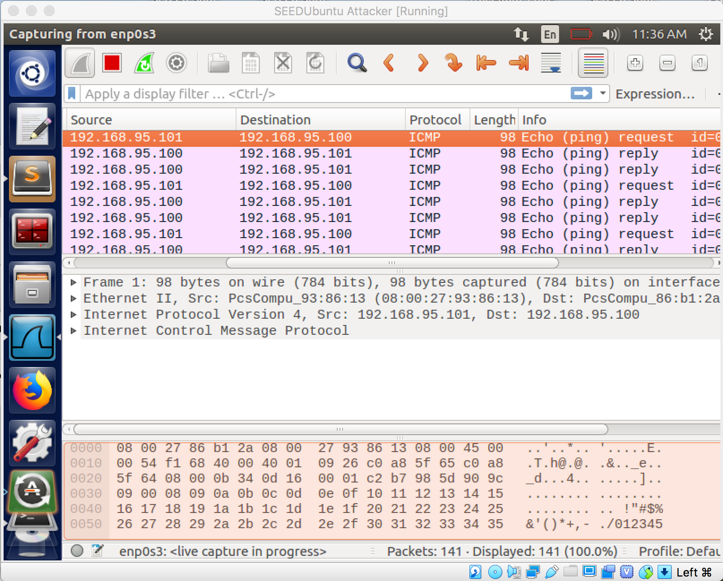

Figure 22: Wireshark is showing here that the Attacker machine has successfully sniffed and spoofed packets coming from the source IP to the destination IP.

Just like when we used Scapy in the python code the goal was to sniff out the packet request being sent to the user machine from the attacker computer and whether alive or off the attacking machine should spoof the IP address of the user machine and reply to the server’s request instead of the user’s machine whether the user’s machine is on or off.